**Team Poker**

Description: A card game for one player with 4 players working together to fill in all available hand types. Score accumulates with card values. Playing the best hands possible is most likely scoring best, but you can save cards for playing later for more points. The UI gives the players cards to use and place in each section as it is possible.

Demo Screen: Explains the game visually, simple logic to play, and allows for screen scaling.

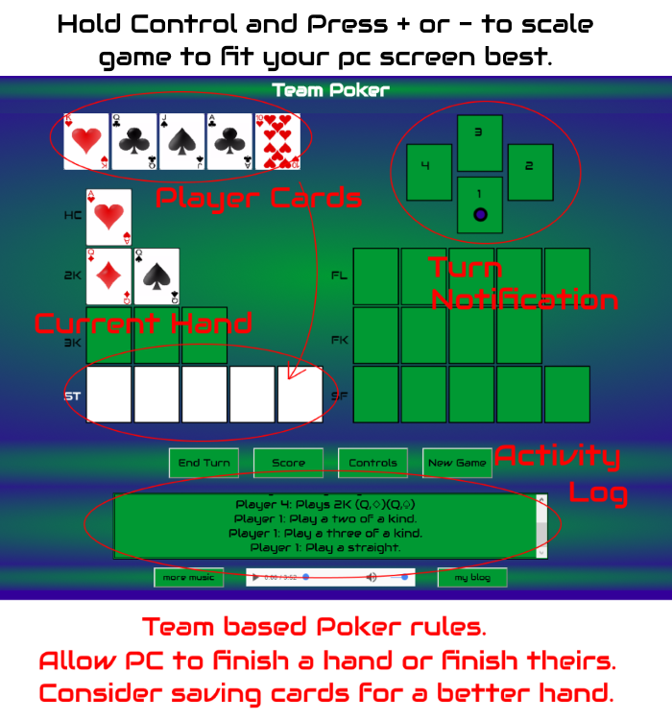

UI: Consists of Drag n Drop or keyboard controls to move cards into open slots of current hand. Allows for ending turn without play, check score, see controls and start a new game.

Focus Points:

1. Cards
   1. 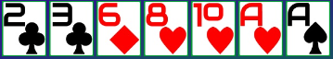
   2. List
      1. Cards are shuffled and dealt into 7 cards to players.
      2. User selects a card and plays it only once per game.
      3. Drag n Drop
      4. 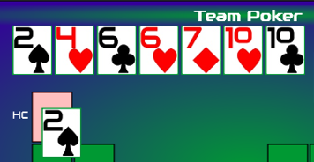
      5. Keyboard Select Drop
      6. 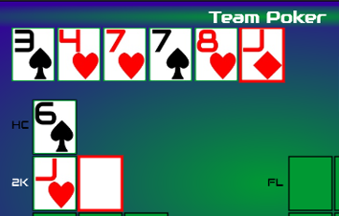
   3. Explain deck
      1. Standard 52 Card Deck of French suited playing cards
      2.    
2. Player Table
   1. The player marker table has a simple faux table layout, 1 indicates player one’s turn and the other three players are all PC players’ this means it will move to the next player automatically. The game cycles through PC player’s automatically as they play or don’t.
   2. 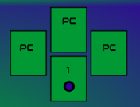
   3. Marker here is at player 3, a PC player.
   4. 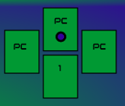
3. Placement Sections
   1. General Rule: Can play a higher card if you want to or play a lower card to save cards for other hands. If PC player plays a card and you play one over it, you now have that replaced card in your deck. Some hands can be partially played to start scoring, PC players must continue with at least one card to allow player to finish.
   2. High Card – High Card played scores value of card. Two of a Kind – Two cards with matching value.
   3. Pair – The Player must play 2 cards to make a scorable pair, same value is needed.
   4. Three of a Kind – Three cards with same value makes a standard three of a kind. Player must play at least 2 cards to let PC finish.
   5. Straight – Five cards must be played to complete, you can play part of it if you think the PC can finish it, with 0 or 3 cards played.
   6. Flush – Any Five card of the same suit must be played to complete a flush, you can play part of it if you think the PC can finish it, with 0 or 3 cards played.
   7. Four of a Kind - Four cards with same value makes a standard four of a kind.
   8. Straight Flush – Five cards in the same suit with consecutive values make a straight flush. Player can play 0 or 3 cards to start hand.
4. Buttons
   1. End turn – Button used to end player turn, moving to PC turns.
   2. Score – Score button explains current score.
   3. 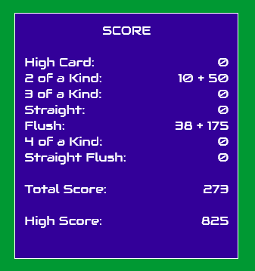
   4. Controls
   5. 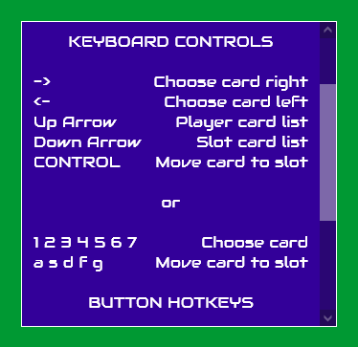
   6. New Game
5. Text Updates
   1. Updates of game as it progresses. It also tells why a play wasn’t able to complete, in case of only 1 card in a four of a kind played, the player will be updated that 2 cards need to be played.
   2. 
6. Music and Blog Section
   1. Allow for music to be played and traverse to my blog.
   2. C:\Users\12067\Pictures\music.PNG